FMDAC
Independent Membership Application

$10.00 Membership per Year

Name:

Address:

City:

State:

Zip Code:

Phone Number:

E-mail Address:

Make check out to FMDAC.
Mail check and form to Treasurer:
Sue Race

Summary of FMDAC Membership Benefits
- Quarterly Issues of FMDAC’s Newsletter
- Access to Regional Quarterly Newsletters
- Informational USPS & Email Mailings
- Discounts at FMDAC Convention Hotels
- Access to FMDAC Metal Detecting Hunts
- National Presence for Metal Detecting Hobby
- Informational Web-site
  - Club Information
  - State Park Information
  - Legislation Alerts & Information
  - Metal Detecting News
  - Forum, Guestbook & Hunt Calendar

FMDAC Web-site: http://www.fmdac.org

FMDAC National Officers

Mark Schuessler
National President
1464 Graft Road
Attica, NY 114011
Ph. (585) 591-0010
Email: KESMAS@localnet.com

Ed Burke
National Vice President
9 Reservoir Road
Dallas, PA 18612
Ph. (570) 310--1530
Email: potogold47@gmail.com

Sue Race
National Treasurer
4349 S Colditz Way
Meridian, ID 83642
Ph. (717) 808-4769
Email: msrace2@gmail.com

Debbie Buxton
National Secretary
3502 Grier Point Rd
Marysville, PA 17053
Ph (717) 853-0282
Email: djb2820@msn.com

Listed within this independent membership brochure are representatives that can direct you to a local club in your area. If you do not have a local club in your area, information about starting your own local club is available on our Website.
To find the nearest local club in your state and or area, please contact the Regional Director that has your state of residence in their area of responsibility.
If you are unable to pinpoint this information, please contact the National Treasurer who has detailed information including the local leadership contact in a local club nearest to you.
Thank you for your interest in the FMDAC.

Throughout America there are thousands of individual purchasers of a variety of metal detectors. Many are not aware of either the FMDAC or of a local contact club in their area.
FMDAC strongly supports the local chapters in every state with our primary goal to secure membership in the FMDAC. This is the beginning, but more importantly, our goal is to increase membership and the education of the hobby to all those now enjoying the hobby with no affiliation with a local club. The FMDAC membership is not intended to bypass any local club, only to enhance and improve the local club membership by promoting and guiding all new independent members to a local club.

FMDAC Regional Directors / Representatives

Don Hayes, Central States
570 Sundale Road, Norwich, OH 43767
Email: dmhayes61@sbcglobal.net
Phone: (740) 872-4217

NV-UT-CO-NE-KS-IO-MO-IL-IN-OH-KY
WV-VA-PA-NJ-DE-MD

Fred Ledtke, Northern States:
864 Parma Center Rd, Hilton, NY 14468
Email: ledtkef@gmail.com
Phone: (585) 509-2178

AK-WA-OR-ID-MT-WY-ND-SD-MN
WI-MI-NY-VT-MA-NH-CT-RI-ME-CANADA

Art DiFilippo, Southeastern States:
203 Village Stone Circle, Summerville, SC 29483
Email: southcacalaky@yahoo.com
Phone: (843) 330-0016

AZ-CA-NM-TX-OK-AK-LA-AL-MS
TN-GA-SC-NC-FL

Membership Chairman

Terry Smith
Membership Chairman
PO Box 455
Judson, Texas 75660
Email: termar@etex.net

Legislative:

Vacant

Where You CAN and CANNOT Detect

National Parks and Federal land are off limits to
detecting.

National Forests vary depending upon the ranger.

Always get permission.

Corp of Engineers: lakes, shoreline and lands.
Permission has been granted only on pre-disturbed
sites such as beaches and attached swimming areas.
Some areas are closed; each area has a district office. Inquire first.

State Parks: Many are open to detecting, however,
many require a permit or permission. Ask a ranger.

BLM land in some areas is open to detecting.
However, environmental rulings are rapidly changing.
It is best to contact a district office in your area.

Public School Grounds: Most are open to detecting
except on ball fields. Look for any signs or city
ordinances forbidding detecting. Check with school
office to be sure.

Colleges, Private Schools: Should be viewed as private property.

Always acquire permission to detect on private property.

Golf Courses, Indian Reservations and Cemeteries are
off limits in most cases.

Be certain to explain that you abide
By the FMDAC Code of Ethics, do
not leave holes, and pick up trash.

FMDAC CODE OF ETHICS

- I WILL ALWAYS CHECK FEDERAL, STATE, COUNTY AND LOCAL LAWS BEFORE SEARCHING. IT IS MY RESPONSIBILITY TO KNOW THE LAW.“

- I WILL RESPECT PRIVATE PROPERTY AND WILL NOT ENTER PRIVATE PROPERTY WITHOUT THE OWNER’S PERMISSION. WHERE POSSIBLE, SUCH PERMISSION WILL BE IN WRITING.

- I WILL TAKE CARE TO REFILL ALL HOLES AND TRY NOT TO LEAVE ANY DAMAGE.

- I WILL REMOVE AND DISPOSE OF ANY AND ALL TRASH AND LITTER THAT I FIND.

- I WILL APPRECIATE AND PROTECT OUR INHERITANCE OF NATURAL RESOURCES, WILDLIFE AND PRIVATE PROPERTY.

- I WILL AS AN AMBASSADOR FOR THE HOBBY, USE THOUGHTFULNESS, CONSIDERATION AND COURTESY AT ALL TIMES.

- I WILL WORK TO HELP BRING UNITY TO OUR HOBBY BY WORKING WITH ANY ORGANIZATION OF ANY GEOGRAPHIC AREA THAT MAY HAVE PROBLEMS THAT WILL LIMIT THEIR ABILITY TO PEACEFULLY PURSUE THE HOBBY.

- I WILL LEAVE GATES AS FOUND.

- I WILL BUILD FIRES IN DESIGNATED OR SAFE PLACES ONLY.

- I WILL REPORT TO THE PROPER AUTHORITIES ANY INDIVIDUALS WHO ENTER AND OR REMOVE ARTIFACTS FROM FEDERAL PARKS OR STATE PRESERVES.

FMDAC Website: http://www.fmdac.org
Feb 2024

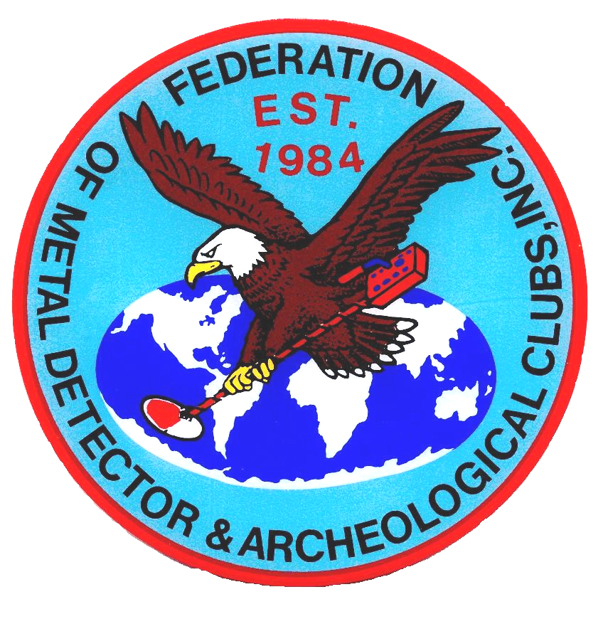
FEDERATION OF METAL DETECTOR AND
ARCHAEOLOGICAL CLUBS INC.

FMDAC Established in 1984

FMDAC was organized in 1984 as a legislative and educational organization to help combat the negative publicity relating to the hobby.

FMDAC is incorporated; a non-profit, non-commercial, non-partisan organization, dedicated to the preservation of the sport / hobby of metal
detecting and recreational prospecting.

FMDAC’s goal is to:

Educate and inform the public as to the merits of the recreational and educational aspects of our hobby.

FMDAC ask that everyone abide by our Code of Ethics, to act in a respectful manner at all times.
Be a proud supporter of the

FEDERATION OF METAL DETECTOR AND
ARCHAEOLOGICAL CLUBS INC.

